Acceleread Accelewrite

What is Acceleread Accelewrite?
- In 1992, talking computer project (Miles and Clifford)
- 2 years revising the programme
- Acceleread Accelewrite published in 1994
- Still being updated, manual reprinted in 2014 to discuss new technology, e.g. ipads

How does Acceleread Accelewrite work?
- Schools download recommended text-to-speech conversion software
- Provided with pack of cards, each has 4 sentences on
- Child works 1:1 with an adult
- Read and memorise a sentence
- Type it into the computer
- Speech feedback after each word and whole sentence read aloud
- If a word has been written incorrectly, child spots mistake and retries
- All 4 sentences on card written this way
- Child and adult discuss common sound pattern in the sentences
- 20 minutes each day for between 4 and 8 weeks

Underlying Principles
- Visual Verbal Associations
  - Mapping of phonemes (smallest sound unit in words) onto graphemes (letter or letters which represent sound)
  - Performance on visual verbal paired associated learning tasks accounts for variance in reading
  - Need phonological awareness and letter knowledge before mapping phonemes and graphemes
  - Multi-sensory approach to build GPC
  - Requires individuals to read sentences, building existing skills to fluency
  - Could adapt approach to use with single words
- Structure of Input
  - GPC introduced in structure reflecting phonics phase list from National Literacy Strategy (2003)
  - Solity has found that children could read 90% of text through learning 64 high frequency GPC and 89 key sight words
- Feedback
  - Task-specific feedback
  - May be perceived as more trustworthy than human feedback
- Support at the Right Level
  - Adult mediate materials so learner moves at correct pace
- Making Mistakes
  - Dealing successfully with errors is a key part of learning
- Technology
  - Enormously motivating, engage reluctant learners
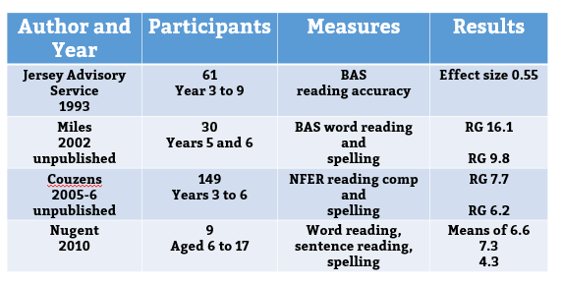
Evidence Base

Implications
- May be effective when children have phonemic awareness and letter knowledge but are struggling to map graphemes onto phonemes.
- Staff need to understand the importance of mediation and making mistakes.
- Schools should adapt the intervention to support the needs of their learners.
- Reading is not built on cognitive skills alone.
- More research is needed.

